User’s Guide for CHAS Excel Files
We understand that many planners and analysts don't have the software or the inclination to mine through the thousands of rows of data we're providing. To accommodate such people, we are providing the data in Excel format and grouping the data into "tables" with various themes. Many users will be perfectly satisfied with Table 1, which provides counts of households at various income levels and in various racial/ethnic groups with housing problems. Other tables focus on specific housing problems, such as cost burden (Tables 8, 9, and 12), overcrowding (Table 10), and substandard housing (Tables 8, 14, and 15). Still other tables focus on specific household types, such as the elderly (Table 5), the disabled (Table 6) and large and small families (Table 4). This guide will show users how to download the data and find the particular numbers that interest them.

Downloading the data
Initially we hoped to format the Excel files to include some features for easy use, but we would have had to manually modify about 1,300 files. Instead, we recommend that you follow these steps when you first download and open your Excel files:
- Download the .zip file and extract the 18 Excel files it contains (36 files if your state has data for minor civil divisions).
- The first time you open each Excel file you will see an error message saying “File error: data may have been lost.” Disregard this message and click OK.
- Create an autofilter on the top row. If using Microsoft Excel 2007, the autofilter button is on the Data tab (see image below). If using Microsoft Excel 2003, click on the Data menu, then Filter, and then AutoFilter.
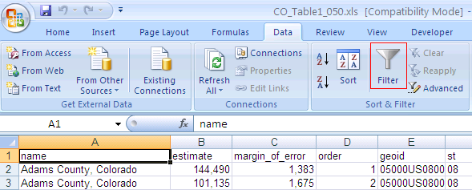
- Set up freeze frames to hold the column headings in place at the top of the screen and to hold the name, estimate, and margin_of_error columns in place at the left of the screen. To do this in Microsoft Excel 2007, first click on cell D2. Then click on the View tab, and select the first Freeze Panes option (see image below). To do this in Microsoft Excel 2003, click on cell D2, then click the Window menu, then click Freeze Panes.
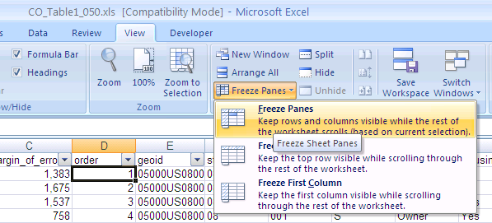
- Save the file. Next time you open it, there will be no error message, and the autofilter and freeze frames functions will still be on.

Using the data
Once you’ve created the autofilters and familiarized yourself with how they function, you will be able to focus in on the particular data elements that you need. For instance, each file has columns labeled name, st, and cnty. Files with data for minor civil divisions also have a column labeled mcd. These allow users to filter the data so that only their area is displayed (note: st, cnty, and mcd use numeric codes known as FIPS codes, or ANSI codes, and can be found here: http://www.census.gov/geo/www/ansi/ansi.html).
Users can also filter the data based on the housing needs characteristics of interest to them, rather than HUD trying to generate a single table that everyone uses. Below are several examples:
Example 1: Getting Basic Data
Planners in Fayette County, Kentucky want to see how many extremely low-income (less than 30% AMI) renter households they have with housing problems. They should go to the <link: Excel data page> and download the file KY-CHAS.zip. This includes all CHAS tables for Kentucky, but Table 1 will suffice for this analysis. After opening the file KY_Table1_050.xls using the directions above, apply the following sequence of filters:
- Filter column A to pick “Fayette County, Kentucky,” or filter column F to select county code 067 (the FIPS code for Fayette County).
- Filter column I (tenure) to select “Renter.”
- Filter column J (housing problems) to select “Yes.”
- Filter column J (household income) to select “30% AMI or less.”
- Filter column K (Race) to select “All.”

Only one row will appear, and the number in the column B ("Estimate") shows that Fayette County has 10,645 renter households with housing unit problems, making less than 30% of the area median family income.

name | estimate | margin_of_error
Fayette County, Kentucky | 10,645 | 885

Example 2: Understanding and Working with Totals and Subtotals
Continuing with Example 1, the Fayette County planners decide they need some context for the number of renter households with housing unit problems, making less than 30% of the area median. They may want to express it as a percentage, and need to choose a denominator.
- One option would be to use the total number of households in the jurisdiction. The simplest way to obtain this number is to filter column H (line_type) by “T,” or to filter column D (order) by “1”. Another way to find the total number of households would be to select “All” on every filter related to household characteristics. For Fayette County, the total number of households is 117,480; so the percentage of total households that rent, have housing problems, and have income less than 30% AMI is 9.1%.
- The preceding statistic isn’t particularly helpful. The planners may want to show how prevalent housing problems are specifically for low income renters. In this case, they need the subtotal of households that rent and have income less than 30% AMI. To get this number, they apply all the same filters from Example 1 except for the Housing Problems filter (step 3). This returns three rows of data: the number of extremely low income renter households with housing problems, without housing problems, and where housing problems could not be determined (Housing_Problems = N/A). Adding these three numbers shows that there are a total of 13,180 renter households with income at 30% AMI or less. Using this as a denominator reveals that 81% of low income renters have housing problems—a much more notable statistic than the 9.1% above!

name | estimate | margin_of_error | Line_Type | Tenure | Housing_Problems | Household_Income | Race
Fayette County, Kentucky | 10,645 | 885 | S | Renter | Yes | 30% AMI or less | All
Fayette County, Kentucky | 1,270 | 354 | S | Renter | No | 30% AMI or less | All
Fayette County, Kentucky | 1,265 | 315 | S | Renter | N/A | 30% AMI or less | All

- Note also that all three rows of data in the preceding table have a Line_Type of S, which indicates subtotal. That is due to the fact that the Race dimension is set to “All.” If you want data for specific racial or ethnic groups, you would use this filter. For instance, you could unselect “All”, and instead select “White” and “Hispanic.” This produces 6 rows of data, all of which have a Line_Type of D, which indicates that all dimensions in the table are active; these are not subtotals. From these data it appears that there are 410 extremely low income Hispanic renter households in Lexington, and 395 of them have housing problems. However, the margins of error on these data are extremely large, so HUD recommends caution when conducting analysis such as this.
name | estimate | margin_of_error | Line_Type | Tenure | Housing_Problems | Household_Income | Race
Fayette County, Kentucky | 7,165 | 674 | D | Renter | Yes | 30% AMI or less | White
Fayette County, Kentucky | 395 | 194 | D | Renter | Yes | 30% AMI or less | Hispanic
Fayette County, Kentucky | 705 | 256 | D | Renter | No | 30% AMI or less | White
Fayette County, Kentucky | 0 | 154 | D | Renter | No | 30% AMI or less | Hispanic
Fayette County, Kentucky | 725 | 227 | D | Renter | N/A | 30% AMI or less | White
Fayette County, Kentucky | 15 | 24 | D | Renter | N/A | 30% AMI or less | Hispanic

Example 3: Using the “order” variable
This section demonstrates a slightly more advanced use of the Excel versions of the CHAS data. Users who have reviewed the data dictionaries know that each combination of a table’s dimensions is uniquely identified by the “order” variable. For instance, in almost every table, the row where order=1 contains the total number of households for each jurisdiction. For table 1, the row where order=2 contains the total number of owner occupied households. Using the order variable is a sort of shortcut, and can facilitate cross-jurisdictional comparisons. Take Example 2A above.
- Order = 128 for the number of extremely low income renter households with housing problems.
- Order = 169 for the number of extremely low income renter households without housing problems.
- Order = 210 for the number of extremely low income renter households where housing problems could not be determined (these households either don’t have housing costs or don’t have income).
If one wanted to compare the housing needs of Lexington with some other jurisdictions, the easiest way would be to use the filter on the order variable to select only these values. Then select other jurisdictions of interest using column A. These steps provide the data necessary for the following table, which shows that extremely low income renters are more likely to have housing problems in the counties of Fayette and Jessamine (around Lexington) than in the counties of Jefferson and Shelby (around Louisville).
Renter households with income at or below 30% of the median:
 | With Housing Problems | Total | Percentage with Housing Problems
Fayette County, Kentucky | 10,645 | 13,180 | 81%
Jessamine County, Kentucky | 1,280 | 1,405 | 91%
Jefferson County, Kentucky | 21,850 | 29,135 | 75%
Shelby County, Kentucky | 740 | 985 | 75%

The only exceptions are Tables 14A and 14B, where the universe is vacant housing units rather than households.

